# ABSTRACT

The Doctor Appointment System streamlines the process of scheduling appointments for medical consultations, offering an automated and user-friendly platform. Traditionally, patients have had to rely on manual methods of appointment scheduling, which are time-consuming, prone to errors, and require extensive paperwork. This system addresses these challenges by providing a web-based solution built on CSS, JavaScript, HTML, MySQL, and PHP technologies, compatible with Windows operating systems. Users, including both patients and administrative staff, can access the system to request, track, and manage appointment bookings efficiently. By automating the process, the system reduces paperwork, minimizes errors, and ensures timely scheduling of appointments. Its successful implementation demonstrates its effectiveness in facilitating a smoother appointment management process for medical institutions, enhancing both doctor and patient satisfaction.

**Keywords: PHP, Database, HTML, CSS, JS**

# ACKNOWLEDGEMENT

We would like to express our special thanks of gratitude to our supervisor Mr. Sagar K.C who gave us the golden opportunity to do this wonderful project on the topic of ‘**Doctor Appointment System’** which also helped us in doing a lot of research and we came to know about so many new tools and technologies.

I would like to express my special gratitude and thanks to our BCA Program Coordinator Mr. Ram Prasad Subedi for his support and help for our personnel development and mainly for the completion of this Project

I am highly indebted to Kathmandu Business Campus for their guidance and constant supervision as well as for providing necessary information regarding the Project and support in the completion.

We would also like to express my gratitude towards library and member of Kathmandu Business Campus for their kind co-operation and encouragement which help me in completion of this Project.

We would also like to thank our parents and friends who helped us a lot in finalizing this project within the limited time frame.

In the end, we would also like to thank Tribhuvan University for giving us this opportunity via the course of Computer Application to help us understand the project ethics at this early stage and helped us to evaluate my knowledge and expand it a little more.

Yours sincerely,

Dipesh Kumar Shrestha

Nishan Mahat

Table of Content

ABSTRACT i

ACKNOWLEDGEMENT ii

LIST OF ABBREVIATIONS v

LIST OF FIGURES vi

LIST OF TABLE vii

Chapter 1: Introduction 8

1.1 Introduction 8

1.2 Problem Statement 9

1.3 Objectives 9

1.4 Scope and Limitation 9

1.4.1 Scope 9

1.4.2 Limitation 9

1.5 Report Organization 10

Chapter 2: Background Study and Literature Review 11

2.1 Background Study 11

2.2 Literature Review 12

Chapter 3: System Analysis and Design 13

3.1 System Analysis 13

3.1.1 Requirement Identification: 14

3.1.2 Feasibility Analysis 15

3.1.3 Data Modeling (ER-Diagram) 17

3.1.4 Process Modeling (DFD) 17

3.2 System Design 19

3.2.1 Architectural Design 19

3.2.2 System Flowchart 19

3.2.3 Database Schema Design 23

3.2.4 Interface Design (UI Interface) 24

Chapter 4: Implementation and Testing 28

4.1 Implementation 28

4.1.1 Tools Used (CASE Tools, Programming Language, Database Platform) 28

4.1.2 Implementation Details of Modules 29

4.1 Testing 31

4.2.1 Test Cases for Unit Testing 31

4.2.2 Test Cases for System Testing 33

Chapter 5: Future Recommendations 36

5.1 Lesson Learnt / Outcome 36

5.2 Conclusion 37

5.3 Future Recommendations 37

5.4 References 38

References 38

Appendix: System Screenshots 39

# LIST OF ABBREVIATIONS

CRUD Create, Read, Update and Delete

CSS Cascading Style Sheet

DFD Data Flow Diagram

ERD Entity Relationship Diagram

HTML Hyper Text Markup Language

JS Java Script

MySQL Microsoft Server Structured Query Language

PHP Hypertext Preprocessor

# LIST OF FIGURES

Figure 3. 1: Waterfall Model of Doctor Appointment System 13

Figure 3. 2: Use Case Diagram of Doctor Appointment System 14

Figure 3. 3: Gantt Chart of Doctor Appointment System 16

Figure 3. 4: ER-Diagram of Doctor Appointment System 17

Figure 3. 5: Level 0 DFD of Doctor Appointment System 18

Figure 3. 6: Level 1 DFD of Doctor Appointment System 18

Figure 3. 7: Architecture Design of Doctor Appointment System 19

Figure 3. 8: Flowchart of Doctor Appointment System for user 20

Figure 3. 9: Flowchart of Doctor Appointment System for doctor 21

Figure 3. 10: Flowchart of Doctor Appointment System for admin 22

Figure 3. 11: Database Schema Design of Doctor Appointment System 23

Figure 3. 12: Login page of Doctor Appointment System 24

Figure 3. 13: Index page of Doctor Appointment System 24

Figure 3. 14: Category page of Doctor Appointment System 25

Figure 3. 15: Doctor info page of Doctor Appointment System 25

Figure 3. 16: Appointment requesting page of Doctor Appointment System 26

Figure 3. 17: Booking Info page of Doctor Appointment System 26

Figure 3. 18: Doctor login page of Doctor Appointment System 26

Figure 3. 19: Doctor Dashboard of Doctor Appointment System 27

Figure 3. 20: Admin Dashboard of Doctor Appointment System 27

# LIST OF TABLE

Table 3. 1: Gantt Chart Table for Doctor Appointment System 16

Table 4. 1: Test Case for Login of User 31

Table 4. 2: Test Case for Login of Doctor 32

Table 4. 3: Test case for login of Admin 32

Table 4. 4: Test case for appointment request (Success) 33

Table 4. 5: Test case for appointment request (Failure) 33

Table 4. 6: Test case for respond to appointment request (Success) 34

Table 4. 7: Test case for updating doctor schedule (Success) 34

Table 4. 8: Test case for updating doctor schedule (Failure) 34

Table 4. 9: Test case for cancel appointment when status is pending 35

Table 4. 10: Test case for request to cancel appointment when status is confirmed 35

Table 4. 11: Test case to delete user 35

Table 4. 12: Test case to delete doctor 35

# Chapter 1: Introduction

## 1.1 Introduction

**“Doctor appointment system”** is a software solution that allows patients to easily book their appointment to a health care provider according to their health issues. This system automates the entire appointment system, from the users submitting appointment request to the health care provider and health care provider confirming their appointment request. This system has been developed to resolve the problems that users experience when taking a doctor appointment by physically visiting for checkup. Moreover, this system is designed for the particular need of the company to carry out operations in a smooth and effective manner.

Doctor appointment system, as described above can lead to fast appointment system. This system enables doctors and health care assistants to manage user’s records and appointments. Doctors can register by providing their required information such as times, fees, category, etc. In this system no formal knowledge is needed for the user to use this system. This system allows health care to monitor user’s appointment on their clinics or hospital.

Every organization, whether big or small, has challenges to overcome and managing the information of appointment, doctor, booking, doctor fees, and doctor schedule. To tackle these challenges, we recommend doctor appointment system. This system is designed to make things easier. It brings all this information into one place and automates many tasks. So, whether your organization is big or small, the “Doctor Appointment System” is here to make handling information easier.

Every organization, whether big or small, has challenges to overcome and managing the information of Appointment, Doctor, Booking, Doctor Fees, Doctor Schedule.

## 1.2 Problem Statement

The problem statement of doctor appointment system in the context of Nepal relates to the challenges faced by users in booking appointment of doctor base on their health issues. In the context of Nepal user often experience longer waiting times when booking doctor appointments, resulting in a significant waste of their precious time.

The primary challenge for organizations involves efficiently booking user appointments while minimizing longer waiting times. Clinics often face difficulties when physically booking appointments for users, especially due to the large number of people. In context of Nepal, numbers of the user have to face difficulties regarding doctor appointment. Many clinics are still relied on physical processes for appointment booking and do not understand the benefits of using an automated system.

## 1.3 Objectives

The main objective of this project is to help users in appointment booking of doctors.

* To provide a user-friendly online appointment booking system that is easy to use and available for all user.
* To provide an efficient system for health care providers to manage doctor and patient detail as well as appointments.

## 1.4 Scope and Limitation

### 1.4.1 Scope

1. Users can view available doctor and schedule appointments.
2. Users can view their appointment information within the booking section.

### 1.4.2 Limitation

1. Patients/User cannot chat or have like video calls with doctors.
2. This system does not have health package feature for patients.

## 1.5 Report Organization

**Introduction**

This chapter deals with the introduction of the system with its objectives and limitations along with the reason why the system is made.

**Background Study and Literature Review**

This chapter summarizes the work that has been carried out in the field of data mining and also describes the features about some existing applications related to the doctor appointment system.

**System Analysis and Design**

This chapter concentrates on outlining the various needs of the system, covering functional and non-functional requirements, feasibility analysis, Entity-Relationship diagrams, Data Flow Diagrams, system design including architecture and database schema, as well as interface design.

**Implementation and Testing**

This chapter highlights the tools utilized in system development, along with implementation details and the results of tests conducted.

**Conclusion and Future Recommendation**

This chapter provides a short summary of the lessons learned, outcomes, and conclusions of the entire project. It explains what has been accomplished and suggests potential areas for further improvement.

# Chapter 2: Background Study and Literature Review

# 

## 2.1 Background Study

For this project, we researched and reviewed some of the related website which provides the facility for doctor appointment. Throughout the research, we get to find out there are very few websites related to doctor appointment system.

We reviewed different website we noticed that the UI wasn’t simple for new users. This could make harder for new users to find the doctors related to their health issues. Most of the doctor appointment system had no registration system for the users but they can make appointment by filling up a form where they get their appointment information through email.

Doctor appointment system relies on manual processes and person interactions for scheduling and managing patient appointments. Patients typically call the healthcare facility to book their appointments, engaging with receptionists or administrative staff who manually check for available slots and make. Appointment details are often recorded in paper appointment books or records, and patients are provided with physical appointment cards as reminders.

The traditional system of booking doctor appointments has long been associated with long wait times, missed appointments, poor patient experiences. Patients are often required to make phone calls during business hours to schedule appointments, which can be time-consuming and frustrating. In addition, the system can be inefficient and costly for healthcare providers, with staff spending significant time on administrative tasks related to appointment scheduling.

So, our main approach is to fix any issues of this web application and to make UI’s as simple as possible for everyone to understand and use. In addition to it we are adding reviews to the doctor’s profile, so new users can learn about other’s experiences. Moreover, adding reviews to doctor’s profile helps new users decide which doctor is best for them. Reading about other’s experience can help users feel more confident and comfortable when selecting a doctor through system.

## 2.2 Literature Review

There are many systems related to doctor appointment system. We recently had studied about different system which works as like this application.

According to the source Design and Implementation of a Patient Appointment and Scheduling System [1] has no proper information about the doctor and patient. There is no proper detail about the doctor and patient. There is not given feedback properly.

According to our findings, DOCTOR’S APPOINTMENT BOOKING APPLICATION [1] boasts a comprehensive database of healthcare providers and facilitates easy appointment scheduling. However, some users have raised concerns regarding its complex interface and occasional technical glitches, which could potentially impede user experience.

Doctor Appointment System, known for its user-friendly interface and efficient appointment management, but it doesn't include a review system for patients to provide feedback on their interactions with healthcare professionals.

Our primary focus is to enhance the functionality of this web application and simplify the user interfaces to ensure accessibility for all users. Additionally, we are introducing a review feature for doctor profiles, enabling new users to learn from others' experiences. By incorporating reviews into doctor profiles, users can make more informed decisions about their choice of doctor. Accessing firsthand experiences of others can instill confidence and ease in users when selecting a doctor through the system.

# Chapter 3: System Analysis and Design

## 3.1 System Analysis

This system follows a sequential process, starting with requirement analysis, design, implementation, testing, and deployment. During requirement analysis, we analyzed both the functional and nonfunctional requirement and system is developed according to the requirement then designing of the system is carried out. After designing, we begin coding and developing the system. Then, we integrate all the parts and test everything. Once testing shows that everything is working as expected, the system proceeds to the deployment phase.

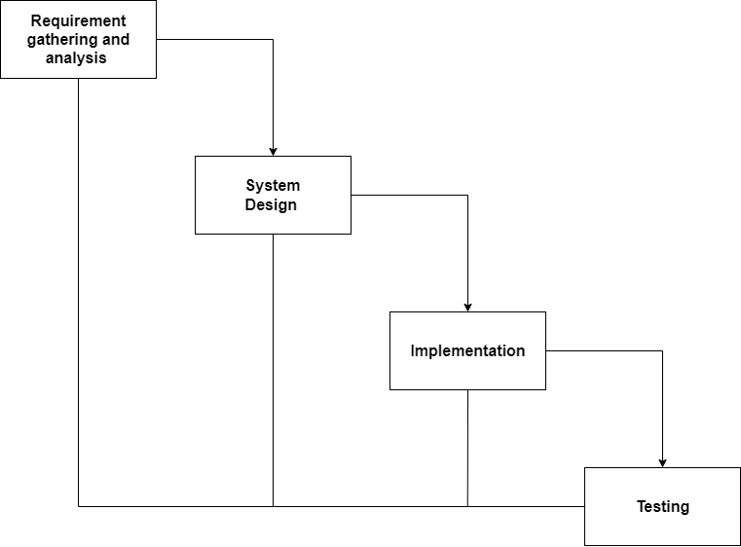

Figure 3. 1: Waterfall Model of Doctor Appointment System

### 3.1.1 Requirement Identification:

Requirement identification is a critical step in the development of any project. To design and develop system, functional as well as nonfunctional requirement of the system has been studied.

**i. Functional requirement**

1. User will able to send request to the doctor for appointment.
2. User will be able to see the list of all doctor as per their specialty.
3. Doctor can accept / reject appointment.
4. Doctor will be able to see list of all appointment.
5. Admin can manage users, doctor.

**Use Case Diagram**

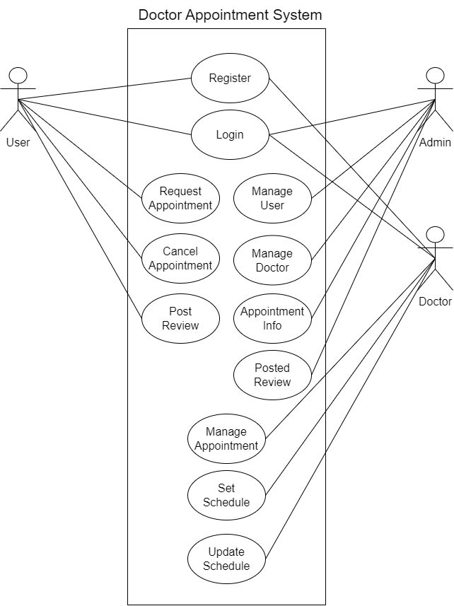

Figure 3. 2: Use Case Diagram of Doctor Appointment System

**ii. Non-Functional requirement**

* **Security**

This system will be secure as the user’s information will not be visible to other users. This system will maintain privacy.

* **Reliability**

This system will be reliable for both the users and doctors.

* **Usability**

This system will be easy to use and navigate, with user-friendly interface.

### 3.1.2 Feasibility Analysis

A feasibility study is a preliminary assessment of a proposed project, plan, or idea to determine whether it is practical, feasible, and economically viable. The purpose of a feasibility study is to identify potential risks, challenges, and opportunities associated with the project. Following feasibility were studied before building the system to see if the system could be built with exact requirement in required time.

1. **Technical Feasibility:**

This system uses existing technologies, software and hardware so there is no technological hurdle to build this system.

1. **Operational Feasibility:**

This system is easy to use because it’s designed with simple technology, making it user-friendly for everyone.

1. **Schedule Feasibility:**

The system is completed within scheduled time and do not exceed the scheduled time.

Table 3. 1: Gantt Chart Table for Doctor Appointment System

|  |  |
| --- | --- |
| **Task name** | **Duration** |
| Planning | 7 days |
| Analysis | 7 days |
| Design | 13 days |
| Coding | 45 days |
| Testing | 7 days |
| Documentation | 79 days |

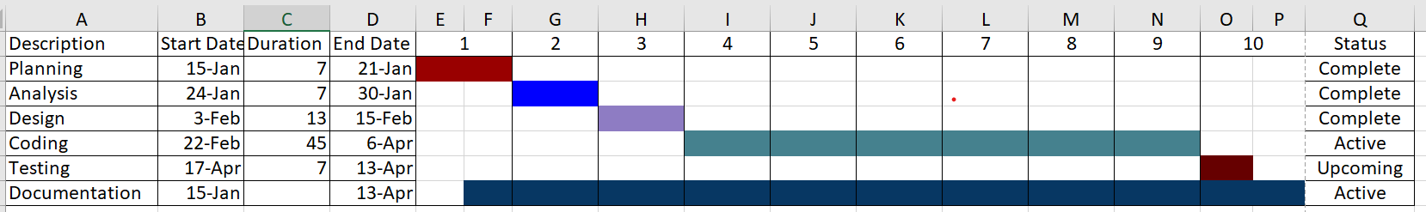

Figure 3. 3: Gantt Chart of Doctor Appointment System

### 3.1.3 Data Modeling (ER-Diagram)

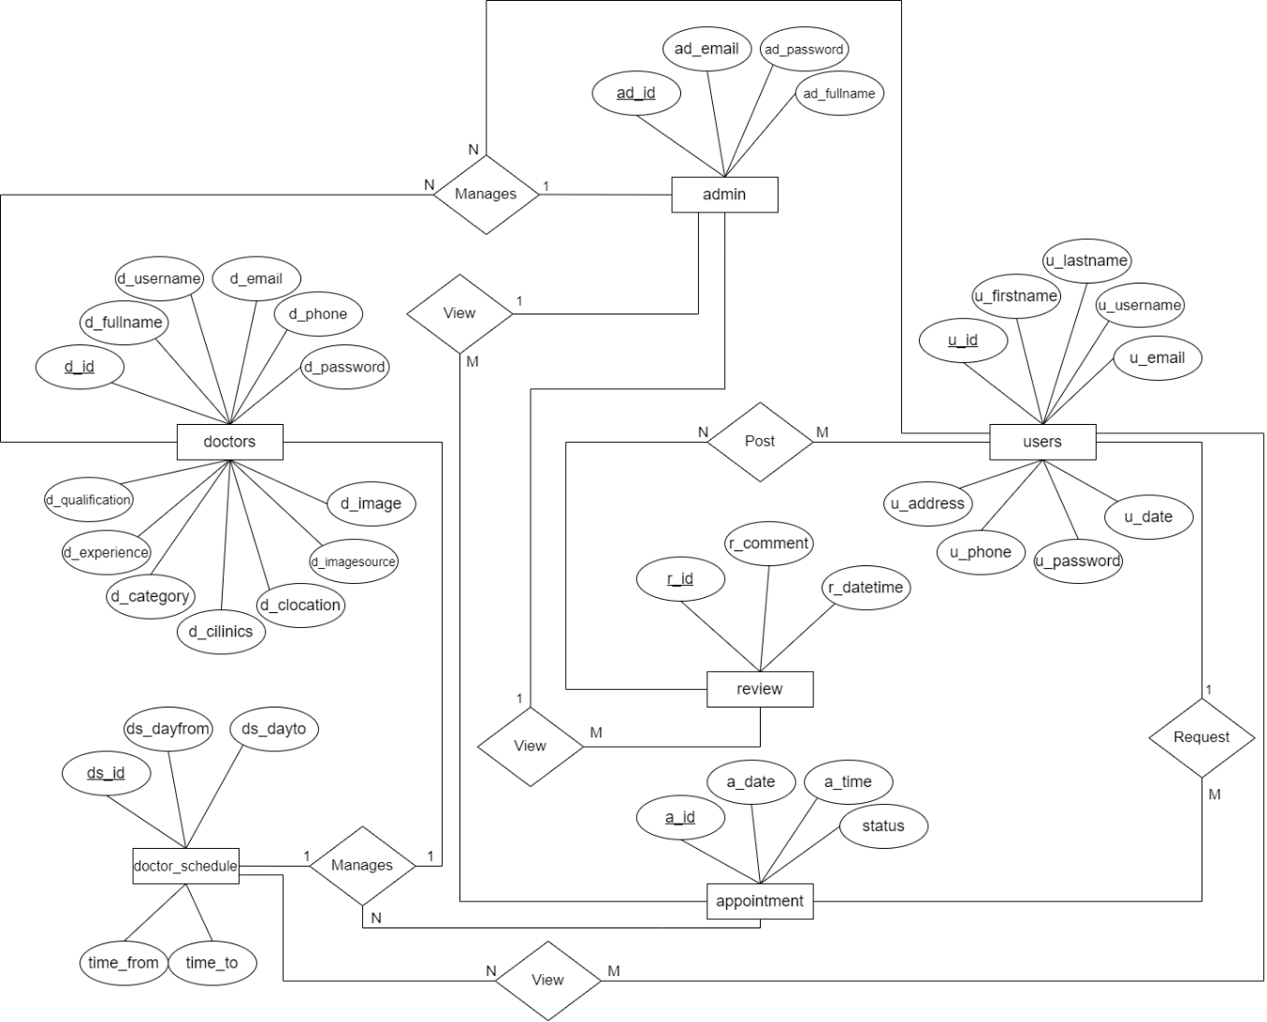

Figure 3. 4: ER-Diagram of Doctor Appointment System

### 3.1.4 Process Modeling (DFD)

The Data Flow Diagram (DFD) of the Doctor Appointment System includes two levels: the level 0 diagram and level 1 DFD. Both levels are essential for creating a comprehensive understanding of the system. In the context diagram, users input appointment information to request an appointment, making appointment information the input for the Doctor Appointment System. The doctor then responds to these appointment requests, resulting in the response becoming the system’s output.

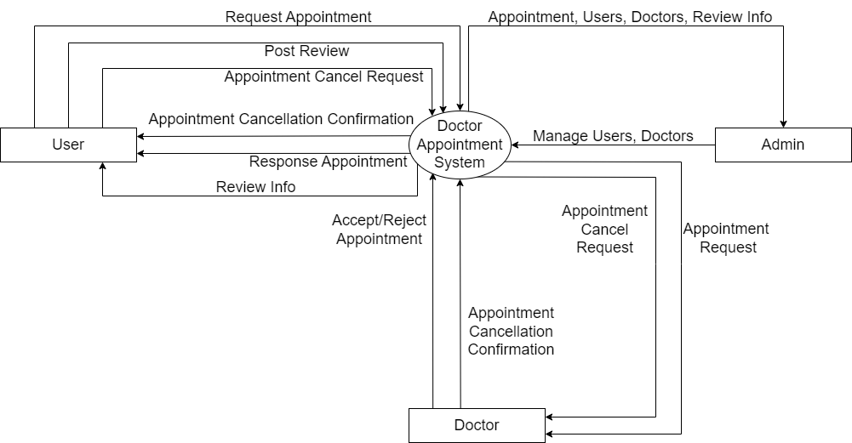

Figure 3. 5: Level 0 DFD of Doctor Appointment System

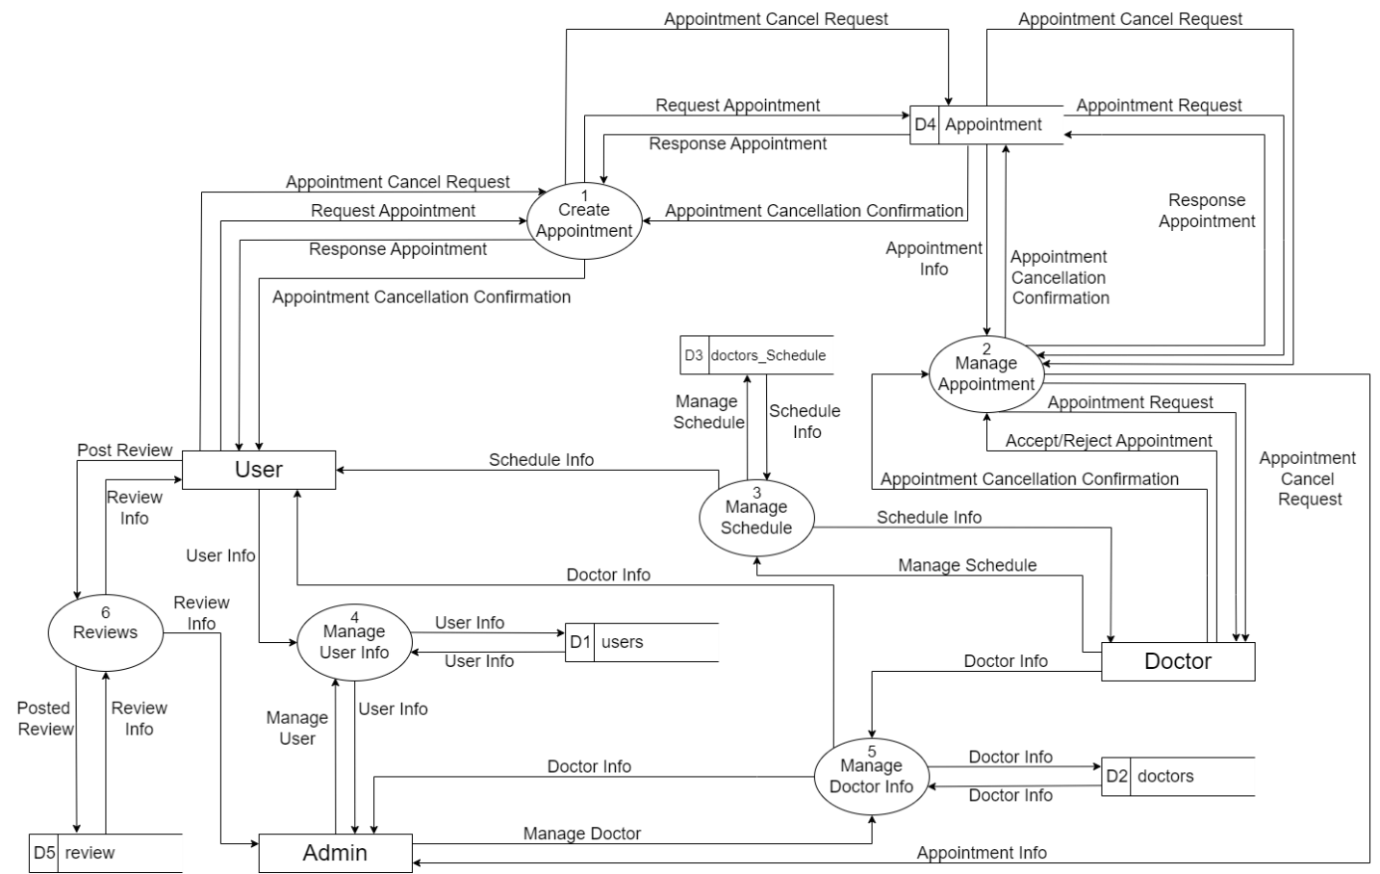

Figure 3. 6: Level 1 DFD of Doctor Appointment System

## 3.2 System Design

To realize the different functional requirement of the system in graphical form, different design diagram of the system has been prepared which are as follows:

### 3.2.1 Architectural Design

For this system, three tier architecture is used that includes user interface, web server and database. Basic structure of the system is shown below:

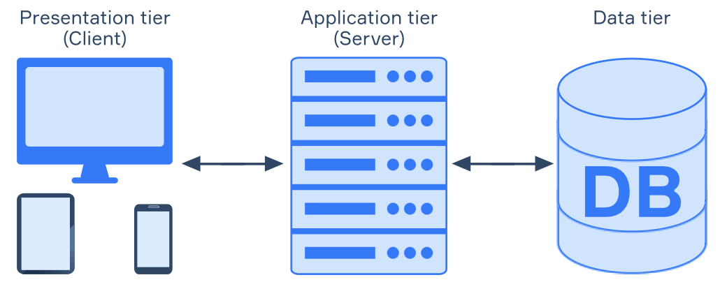

Figure 3. 7: Architecture Design of Doctor Appointment System

### 3.2.2 System Flowchart

The figure below is the flowchart of Doctor Appointment System. Here, admin, doctors and user’s login the system and the admin do not need to register they can directly login the system and for the doctors and users if doctors and users have not register then they need to register first. After login success, it redirects to dashboard. Users can select doctor and view information of doctor, set appointment and also post feedback to the doctor. Doctor can view appointment request and response to the users. Admin can manage users, doctors and view appointment.

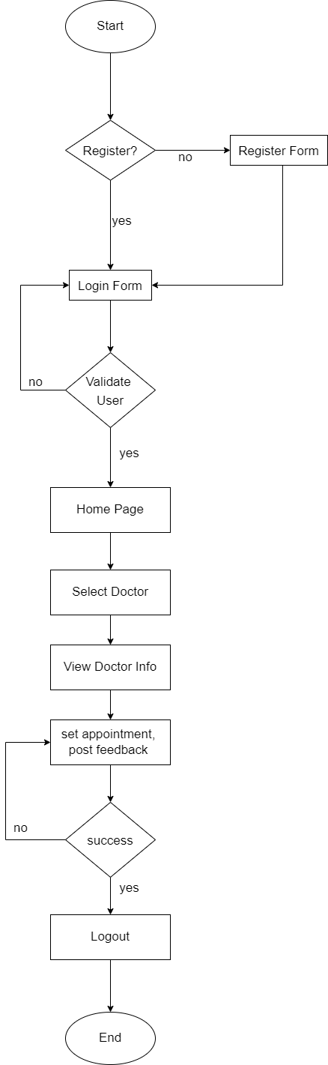**For Users**

Figure 3. 8: Flowchart of Doctor Appointment System for user

**For Doctors**

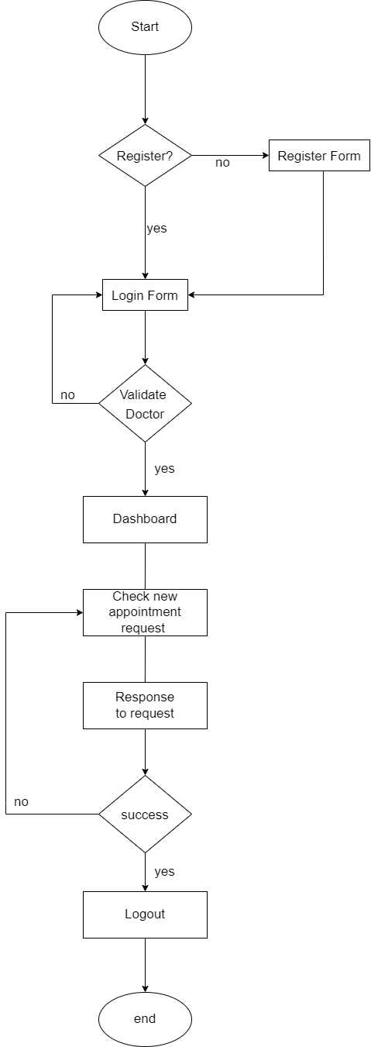

Figure 3. 9: Flowchart of Doctor Appointment System for doctor

**For Admin**

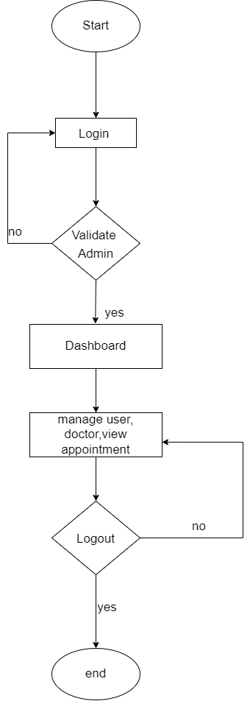

Figure 3. 10: Flowchart of Doctor Appointment System for admin

### 3.2.3 Database Schema Design

The figure below is the database schema design of Doctor Appointment System. Database schema design is used to show basic structure of the system. In doctor appointment system, there are 6 tables in the database each of them has their own fields where their id is primary key and if that id is user in another table, it becomes foreign key and foreign key are connected to another table with line.

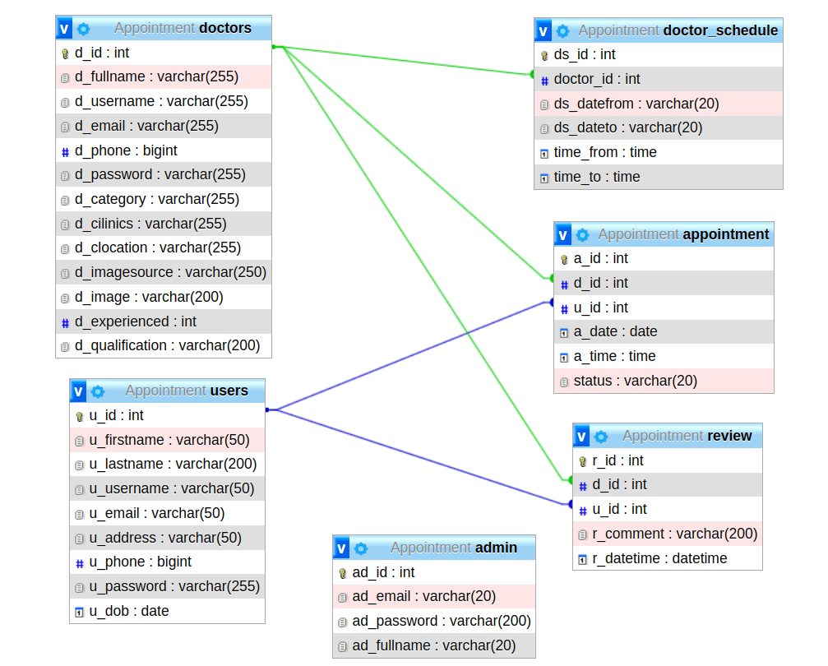

Figure 3. 11: Database Schema Design of Doctor Appointment System

### 3.2.4 Interface Design (UI Interface)

Interface design determines the visual appearance of the Doctor Appointment System and showcases how the system will look to users. Once the design is finalized, system development begins. The UI design pages such as the login page, dashboard page, appointment application page, request viewing page, and appointment management page.

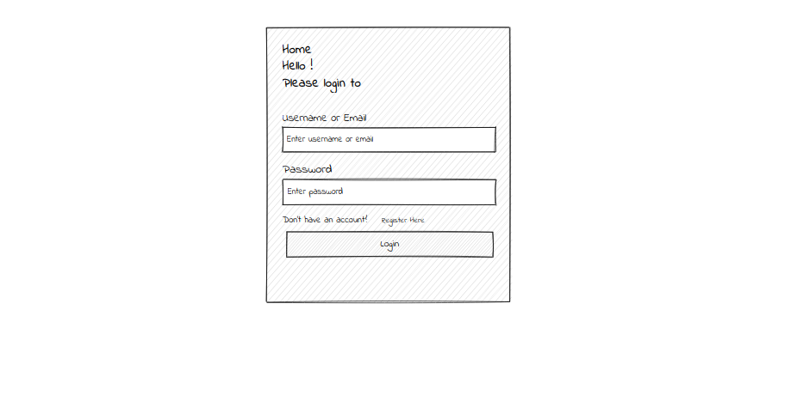

Figure 3. : Login page of Doctor Appointment System

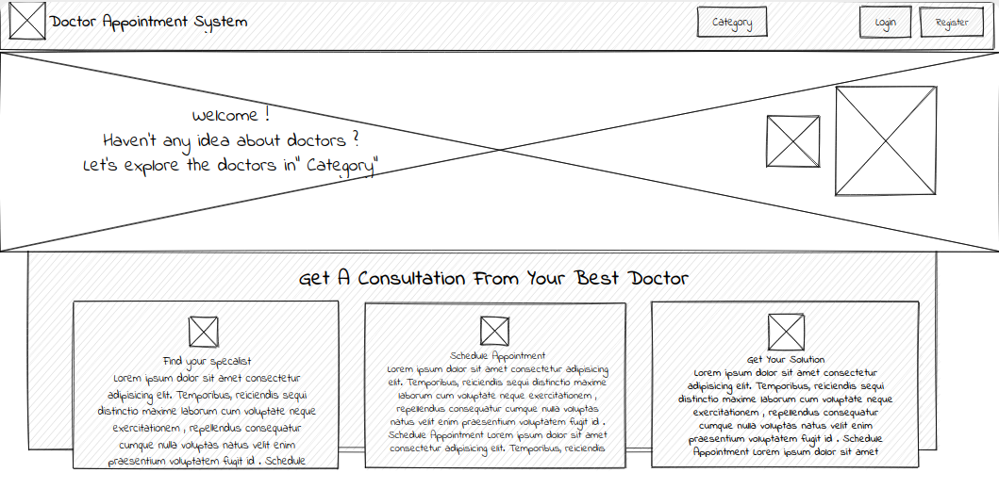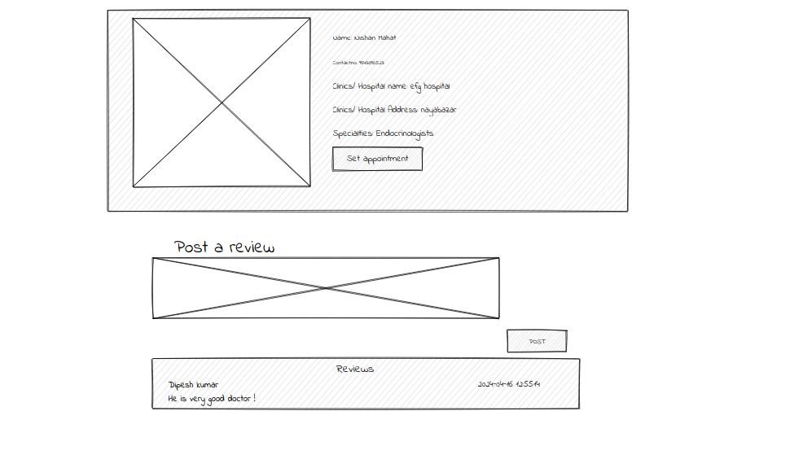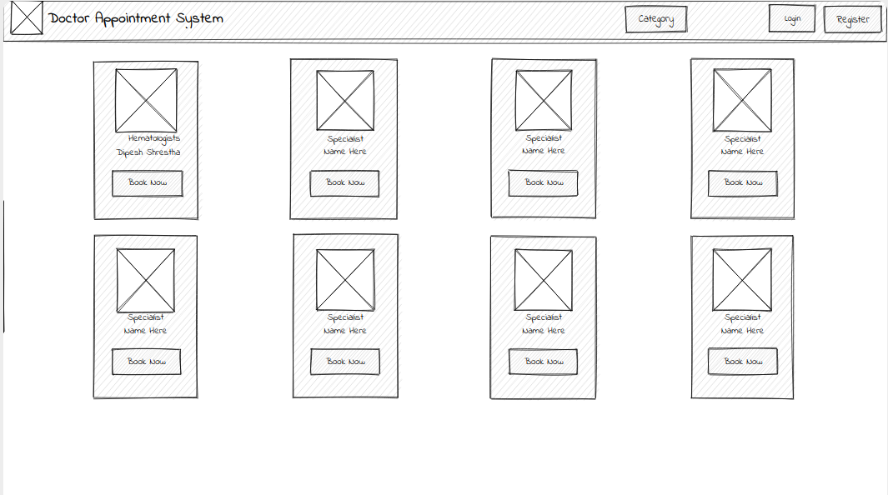

Figure 3. : Index page of Doctor Appointment System

Figure 3. : Category page of Doctor Appointment System

Figure 3. : Doctor info page of Doctor Appointment System

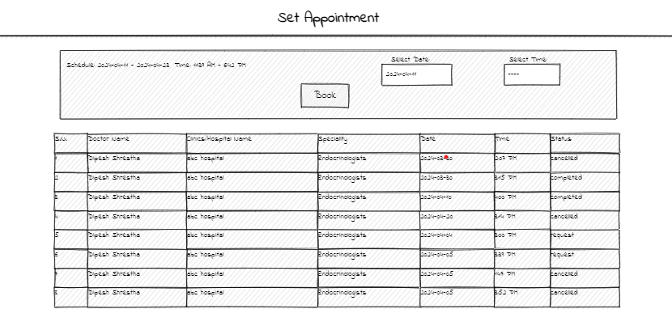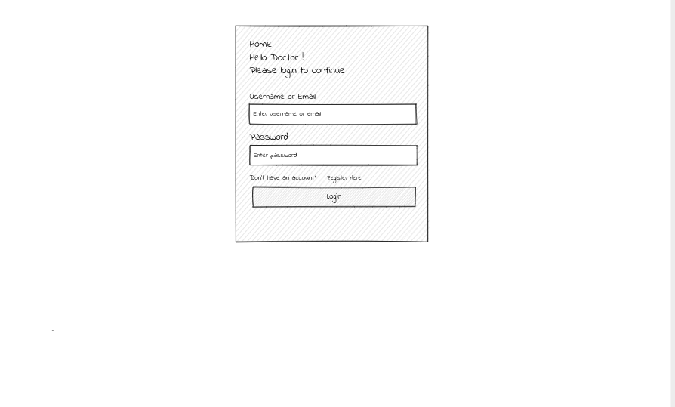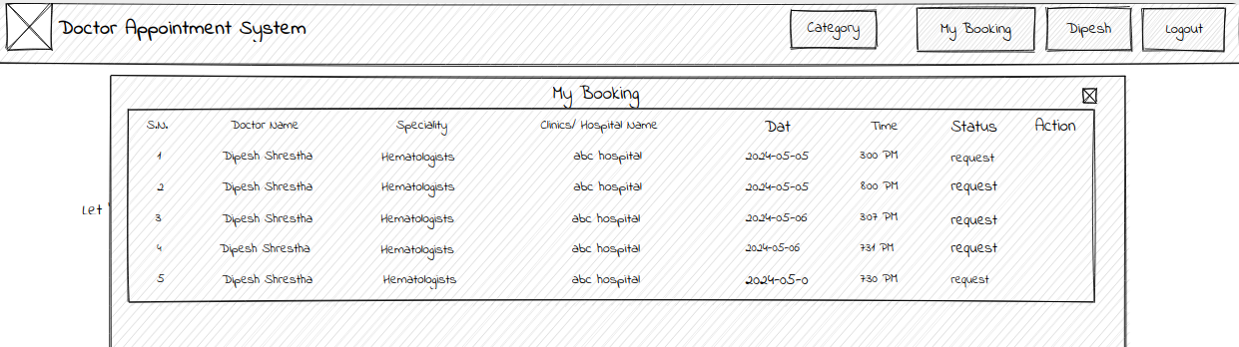

Figure 3. : Appointment requesting page of Doctor Appointment System

Figure 3. : Booking Info page of Doctor Appointment System

Figure 3. : Doctor login page of Doctor Appointment System

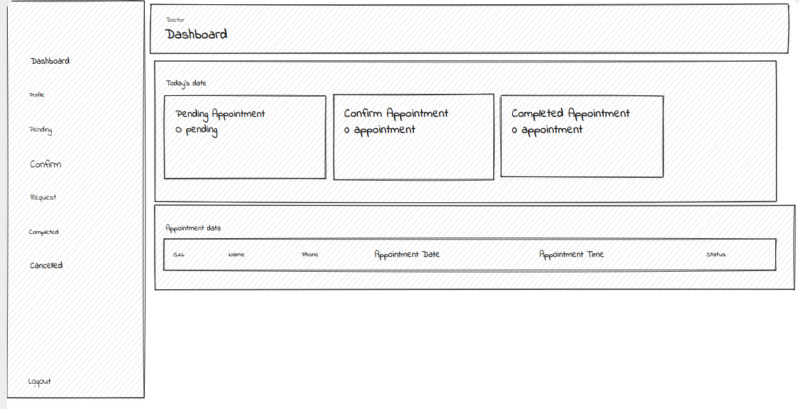

Figure 3. : Doctor Dashboard of Doctor Appointment System

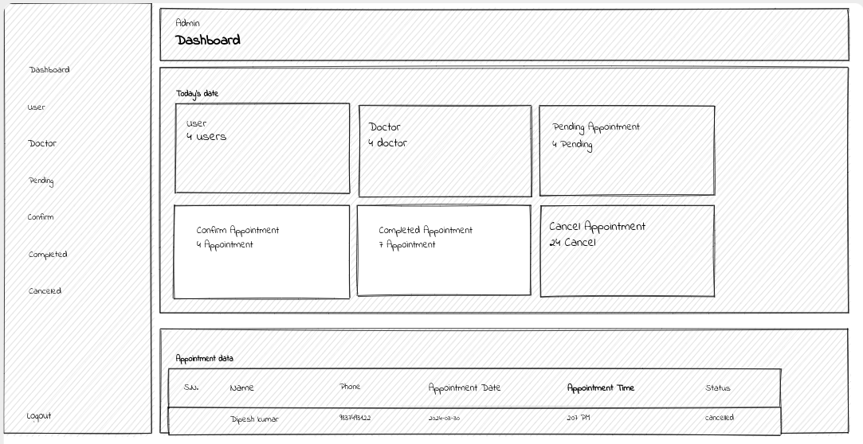

Figure 3. : Admin Dashboard of Doctor Appointment System

# Chapter 4: Implementation and Testing

## 4.1 Implementation

### 4.1.1 Tools Used (CASE Tools, Programming Language, Database Platform)

Following are the tools and framework used for the accomplishment of this project:

**Front-End:**

* + **HTML:** HTML, or Hypertext Markup Language, is the standard language for creating web pages, utilizes tags and elements to structure and design content. Each element is defined by a pair of tags, enclosing content to specify its display. Elements encompass headings, paragraphs, images, links, lists, forms and more. HTML facilitates embedding multimedia content such as images, videos, and audio. Attributes within tags offer additional information or functionality. HTML forms the backbone of webpages, providing the fundamental structure and content visible and interactable in web browsers.
  + **CSS:** CSS, or Cascading Style Sheets, is a language used to control the presentation and layout of web pages written in HTML or XML. By using CSS, we can control the text color, font style, the spacing between paragraphs, sizing of columns, layout designs, and many more.
  + **JavaScript:** JavaScript is a high-level programming language primarily used for adding interactivity and dynamic behavior to websites. JavaScript is used for client-side validation and to make dynamic, interactive and responsive web pages. It is used to add dynamic behavior to the webpage and add special effects to the webpage.

**Back-End:**

* **PHP:** PHP, which stands for Hypertext Preprocessor, is a popular open-source scripting language specifically designed for web development. Unlike JavaScript which runs on your browser, PHP code runs on the server behind the scenes. This allows it to create dynamic web pages.

**Server**

* **APACHE SERVER:** In doctor appointment system, Apache server is used to run PHP files and creating fast and dynamic web pages.

**Database**

* **MYSQL:** MySQL is popular open-source relational database management system (RDBMS) that is commonly used in website design and development. It provides a reliable and scalable solution for storing, managing, and retrieving data for websites. MySQL allows you to create and manage database to store website data efficiently. It is used performing CRUD operation such as create, delete and update data from the database as requested by the user.

**Documentation Tools**

* **MS Office:** This is used for writing and editing the documentation of doctor appointment system.
* **Draw.io:** This is used to generate diagrams for system analysis and design of doctor appointment system. Diagrams were created using this tool in order to save time since all components are available with drag and drop functions.

### 4.1.2 Implementation Details of Modules

Different system of this modules are described as below:

**Admin module:**

* **Admin manages users and doctors**

In this module, admin can perform view and delete. The admin can view all the information of users and doctors and delete the information of any users and doctors.

* **Admin views all appointment**

Admin not only views the users and doctors but also views the appointment they have made. Admin not only views appointment but also view the total appointment doctors have made. Admin doesn’t respond to the appointment request of users but only view them.

**Doctor module:**

* **Doctor views appointment request**

Doctor can view all the appointment request users have made. Doctor can view information about each appointment request, including the user’s name, contact details, preferred date and time.

* **Doctor manages appointment request**

Doctor manage the appointment request from the users. Doctor respond to the appointment requests of the users i.e. they either approve or reject the request. Doctor can view the cancel appointment.

* **Doctor manages schedule**

Doctor can update their schedule as needed to accommodate changes in availability. This flexibility ensures that the schedule accurately reflects the doctor’s availability for appointments.

**User module:**

* **User apply for appointment request**

User apply for appointment request. They have to select doctor and select available appointment date and time and apply it which is received by user selected doctor.

* **User view and cancel appointment request**

User can view their appointment history. They can check status of their appointment request. They can also cancel their appointment request but only if the status of appointment request is pending or else if status of appointment request is confirmed then they can request to cancel the appointment.

**Login module:**

In login module, we have implemented three submodules they are admin login, doctor login and user login. Admin, doctor and user log into the system using their valid username/email and password.

## 4.1 Testing

System testing means of the system using various testing datasets. System testing is one of the most important phases. This test is done to evaluate whether the system is providing accurate summary or not. During the phase of the development of the system, our system is tested time and again. The series of testing conducted are as follow:

### 4.2.1 Test Cases for Unit Testing

In unit testing, we designed the entire system in modularized pattern and each module is tested. Until we get the accurate output from the individual module, we work on the same module. The input form is tested so that they do not accept invalid output.

Table 4. 1: Test Case for Login of User

|  |  |  |  |  |  |
| --- | --- | --- | --- | --- | --- |
| **S.N** | **Test Name** | **Input** | **Expected Output** | **Actual Output** | **Test Result** |
| 1 | Visit website | http://localhost/Appoint  ment/login.php | Login Page | Login Page | Success |
| 2 | Invalid Credentials | username = dipesh87  Password = dipesh12  Email = dipeshshrestha  2@gmail.com | Login success | Login Fail | Success |
| 3 | Valid Credentials | username = dipesh87  Password = dipesh123  Email = dipeshshrestha  2@gmail.com | Login success | Login Success,  Home Page | Success |

Table 4. 2: Test Case for Login of Doctor

|  |  |  |  |  |  |
| --- | --- | --- | --- | --- | --- |
| **S.N** | **Test Name** | **Input** | **Expected Output** | **Actual Output** | **Test Result** |
| 1 | Visit website | http://localhost/Appoint  ment/doctorlogin.php | Login Page | Login Page | Success |
| 2 | Invalid Credentials | username = nishan23  Password = nishan12  Email = nishan23@  gmail.com | Login success | Login Fail | Success |
| 3 | Valid Credentials | username = nishan23  Password = nishan123  Email = nishan23@  gmail.com | Login success | Login Success,  Doctor Dashboard | Success |

Table 4. 3: Test case for login of Admin

|  |  |  |  |  |  |
| --- | --- | --- | --- | --- | --- |
| **S.N** | **Test Name** | **Input** | **Expected Output** | **Actual Output** | **Test Result** |
| 1 | Visit admin route | http://localhost/admin/  login.php | Login Page | Login Page | Success |
| 2 | Invalid Credentials | Email = admin@admin  .com  Password = admin | Login success | Login Fail | Success |
| 3 | Valid Credentials | Email = admin@admin  .com  Password = admin123 | Login success | Login Success,  Admin Dashboard | Success |

### 4.2.2 Test Cases for System Testing

Table 4. 4: Test case for appointment request (Success)

|  |  |
| --- | --- |
| **Test Name** | **Input** |
| Test Data | Category = Hematologists,  Available Date = 2024-05-04 – 2024-05-23,  Available Time = 8:00 AM – 8:00 PM,  Current Date = 2024-05-05,  Current Time = 1:00 PM,  Selected Date = 2024-05-06,  Selected Time = 5:00 PM |
| Expected Result | Show request in doctor pending section |
| Test Result | Success |

Table 4. 5: Test case for appointment request (Failure)

|  |  |
| --- | --- |
| **Test Name** | **Input** |
| Test Data | Category = Hematologists,  Available Date = 2024-05-04 – 2024-05-23,  Available Time = 8:00 AM – 8:00 PM,  Current Date = 2024-05-05,  Current Time = 1:10 PM,  Selected Date = 2024-05-05,  Selected Time = 12:00 PM |
| Expected Result | Invalid Time |
| Test Result | Fail |

Table 4. 6: Test case for respond to appointment request (Success)

|  |  |
| --- | --- |
| **Test Name** | **Input** |
| Test Data | Username = Dipesh Shrestha,  User phone = 9843696532,  Appointment Date = 2024-05-06,  Appointment Time = 5:00 PM,  Appointment Status = pending |
| Expected Result | Show appointment in pending section |
| Test Result | Success |

Table 4. 7: Test case for updating doctor schedule (Success)

|  |  |
| --- | --- |
| **Test Name** | **Input** |
| Test Data | Date From: 2024-05-06,  Date To: 2024-05-14,  Time From: 8:32 AM,  Time To: 5:36 PM, |
| Expected Result | Show in doctor profile |
| Test Result | Success |

Table 4. 8: Test case for updating doctor schedule (Failure)

|  |  |
| --- | --- |
| **Test Name** | **Input** |
| Test Data | Date From: 2024-05-06,  Date To: 2024-05-14,  Time From: 9:00 AM,  Time To: 9:00 PM, |
| Expected Result | Invalid Time |
| Test Result | Fail |

Table 4. 9: Test case for cancel appointment when status is pending

|  |  |  |  |  |  |
| --- | --- | --- | --- | --- | --- |
| **S. N** | **Test Name** | **Input** | **Expected Output** | **Actual Output** | **Test Result** |
| 1 | Cancel  Appointment | Click Cancel button Once | Your appoi-  ntment is cancelled | Your appointment is cancelled | Success |

Table 4. 10: Test case for request to cancel appointment when status is confirmed

|  |  |  |  |  |  |
| --- | --- | --- | --- | --- | --- |
| **S. N** | **Test Name** | **Input** | **Expected Output** | **Actual Output** | **Test Result** |
| 1 | Request  Appointment | Click Request button Once | Appointment cancellation request is sent | Appointment cancellation request is sent | Success |

Table 4. 11: Test case to delete user

|  |  |  |  |  |  |
| --- | --- | --- | --- | --- | --- |
| **S. N** | **Test Name** | **Input** | **Expected Output** | **Actual Output** | **Test Result** |
| 1 | Delete  User | Click Delete button Once | User delete success | User delete success | Success |

Table 4. 12: Test case to delete doctor

|  |  |  |  |  |  |
| --- | --- | --- | --- | --- | --- |
| **S. N** | **Test Name** | **Input** | **Expected Output** | **Actual Output** | **Test Result** |
| 1 | Delete  Doctor | Click Delete button Once | Doctor delete success | Doctors delete success | Success |

# Chapter 5: Future Recommendations

## 5.1 Lesson Learnt / Outcome

Every project makes us to learn and gain the knowledge in different aspects. In the following project, we have learned lots of problem-solving skills and learn things like team

work, finding the solution on our own, proper use of guidelines, communication and writing

skills and management of team.

* **Teamwork**

Since this is a team project, we’ve learned how to share tasks among team members and support each other when things don’t go as planned. We’ve become good at solving problems and fixing errors that pop up in the system.

* **Problem-Solving Skills**

From this project, we have learned lots of problem-solving skills and also learned to recognize different errors occur in this system and solve it.

* **Writing Skills**

During this project, we’ve learned how to create proposals and project documentation. We’ve also become familiar with various case tools for making diagrams like use case diagrams, schema diagrams, data flow diagrams, and ER diagrams.

* **Time Management**

The most important lesson learnt was management of time according to the complexity of the system components i.e. know which components to prioritize.

## 5.2 Conclusion

The 'Doctor Appointment System' project has successfully met its initial objectives. It has created an intuitive platform that simplifies the process of scheduling and managing doctor appointments. By facilitating collaboration and optimizing appointment management, it enhances the experience for both patients and healthcare providers. This system also provides easy and smooth user interface that can be used by non-technical users.

## 5.3 Future Recommendations

We could have managed the development project more efficiently by focusing on design and development before diving into documentation. We should prioritize updating the system based on user feedback to ensure it meets their needs effectively. Also, enhancing page load and server load speeds would contribute to a faster and smoother user experience.

Some of the future recommendations are given below:

* Search functionality can be added.
* Appointment remainder can be added.

## 5.4 References

# References

|  |  |
| --- | --- |
| [1] | J. L. O. S. Akinode, "Design and Implementation of a Patient Appointment  and Scheduling System," 2017. [Online]. Available:https://www.researchgate.net/  profile/Akinode-JohnLekan/publication/332864696_Design_and_Implementation_  of_a_Patient_Appointment_and_Scheduling_System/links/5ccdf7c2a6fdcc  c9dd8d4628/Design-and-Implementation-of-a-Patient-Appointment-and-Scheduling-System.. |
| [2] | D. J. M. S. Ari Subhi, "Doctor Appointment System," 2022 - 2023. [Online].  Available: https://lfu.edu.krd/wp-content/uploads/2023/06/20230620_074338_  compressed.pdf. |
| [3] | D. S. H. R. ,. N. K. Anjulee Pariyar, "DOCTOR’S APPOINTMENT  BOOKING APPLICATION," 2023. [Online]. Available: https://www.e-afr.org  /article/view-2023/pdf/3143.pdf. |
| [4] | E. Gondre and Grabowski, "Problems of Computer Keyboarding in an EFL Context,  " *Writing Research,* pp. 27-52, 2008. |
| [5] | "draw.io," [Online]. Available: https://app.diagrams.net/. |

# 

# Appendix: System Screenshots

* **Database Overview**
* **User Database:**

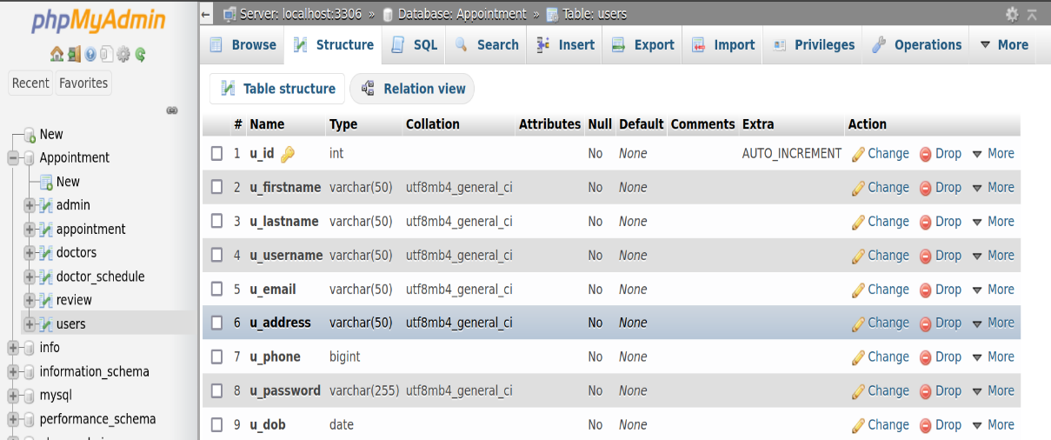

* **Doctor Database:**

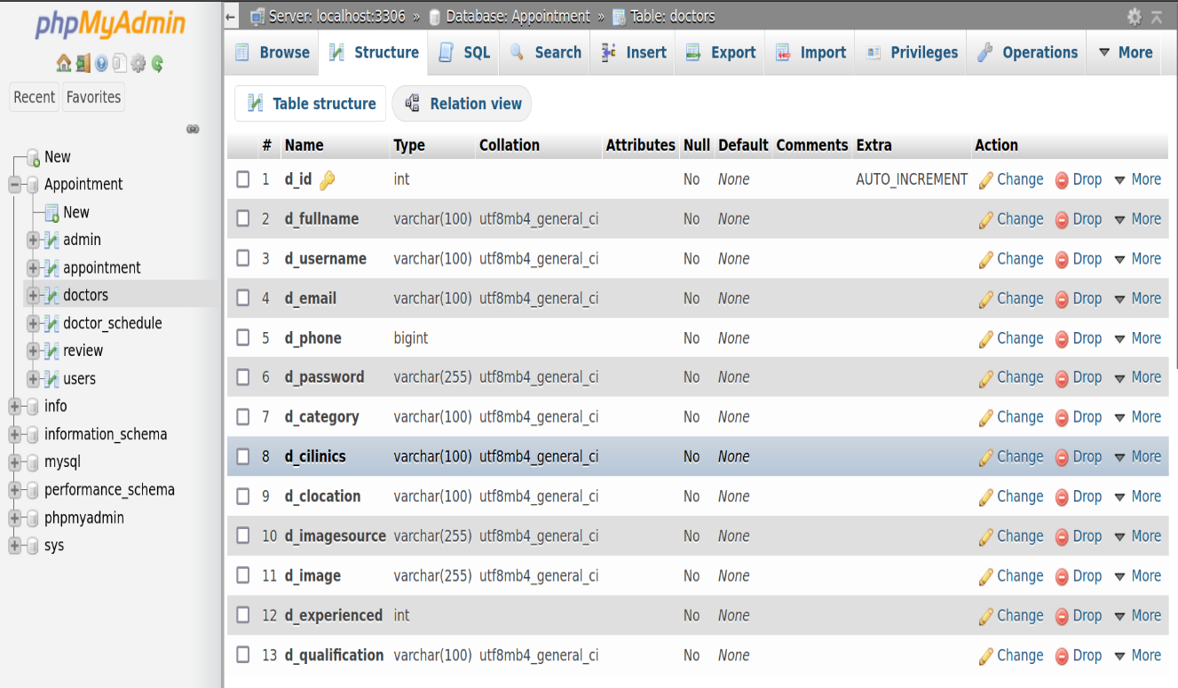

* **Admin Database:**

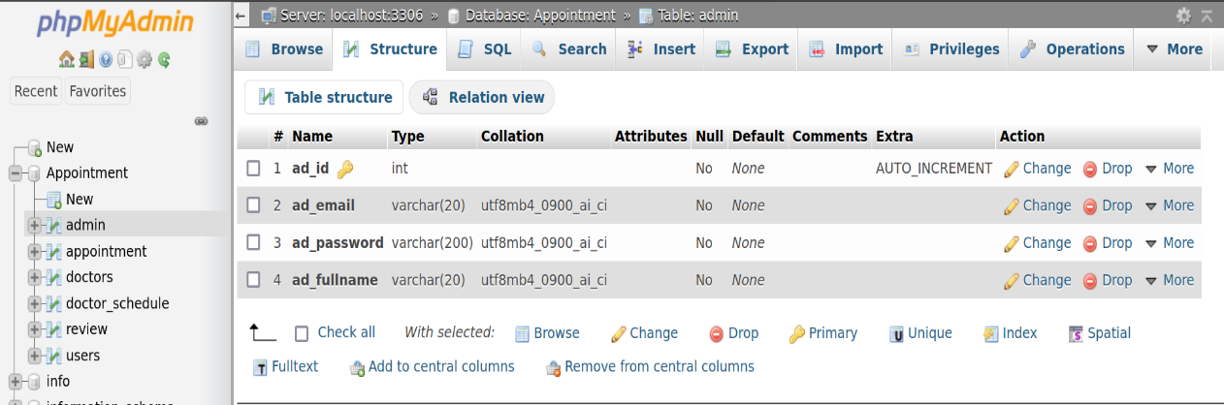

* **Appointment Database:**

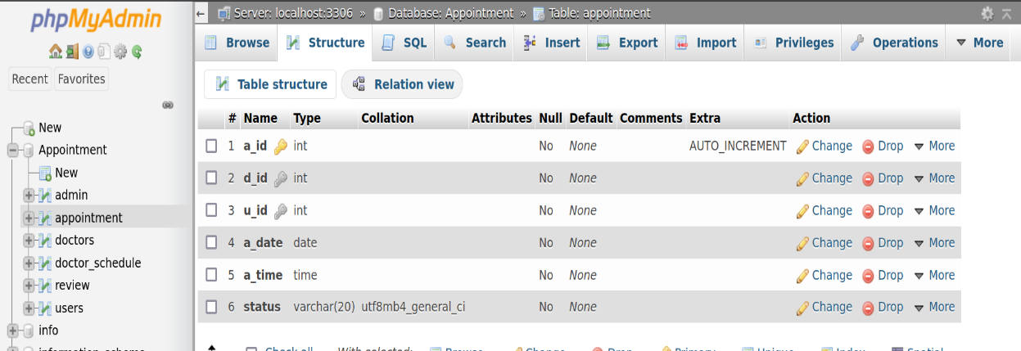

* **Doctor Schedule Database:**

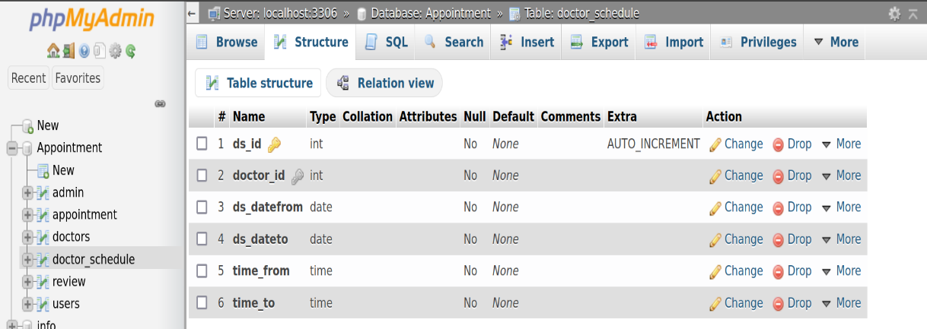

* **Review Database:**

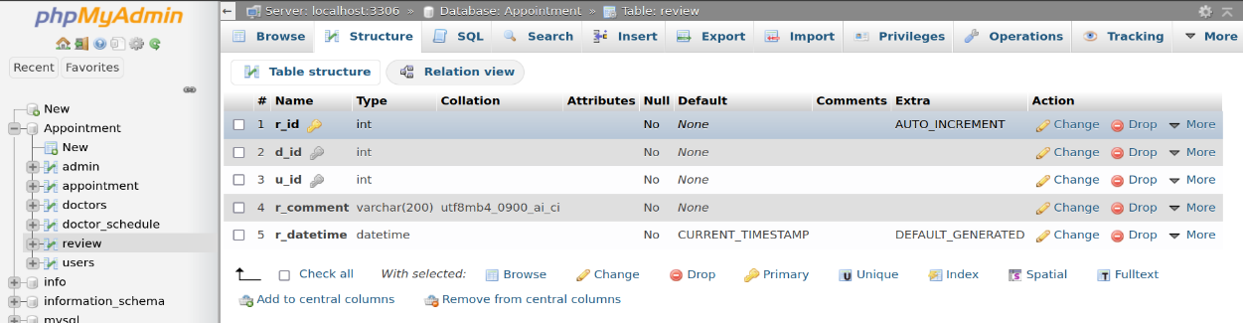

* **Frontend Overview**
* **Login Page:**

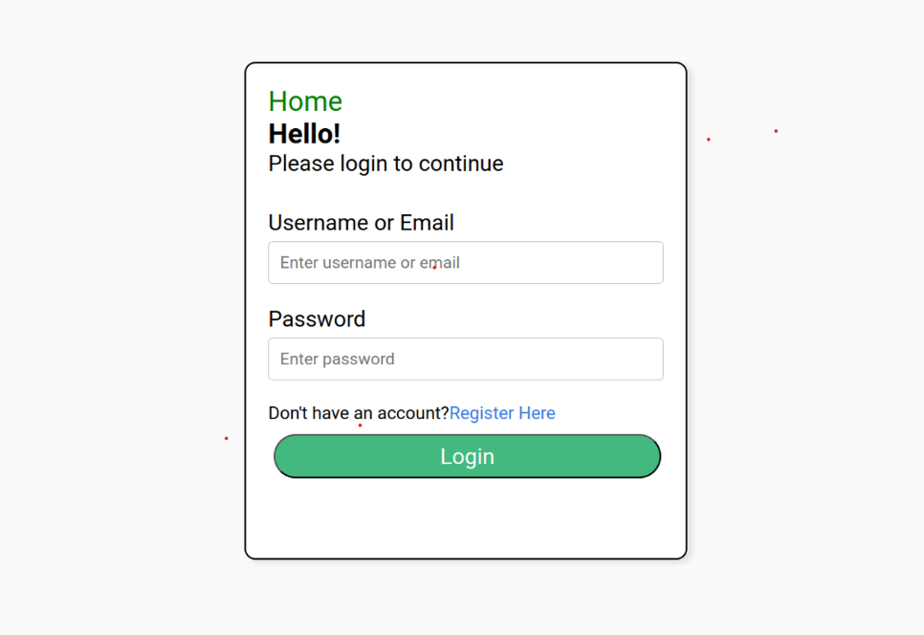

* **Home Page:**

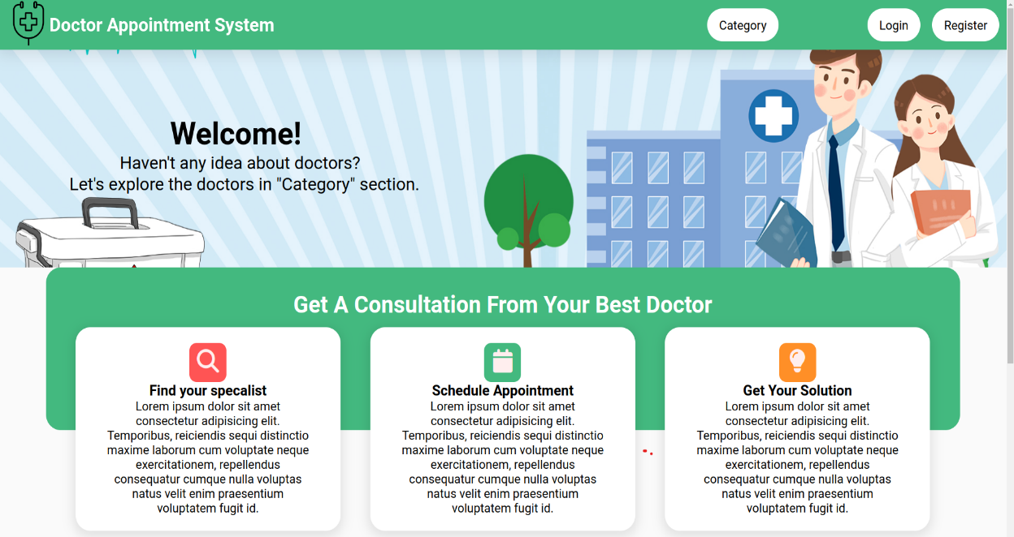

* **Category Page:**

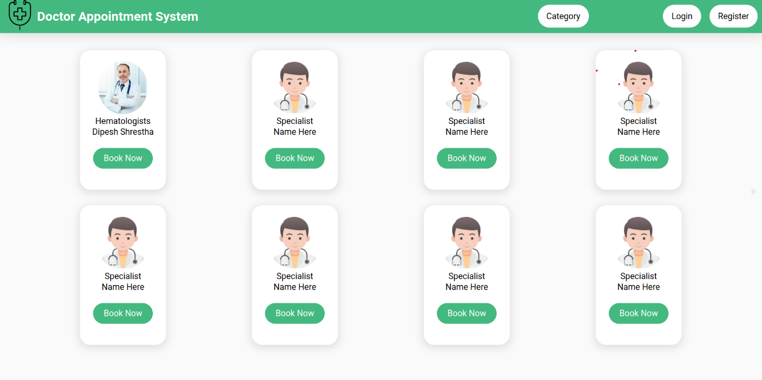

* **Doctor Info Page:**

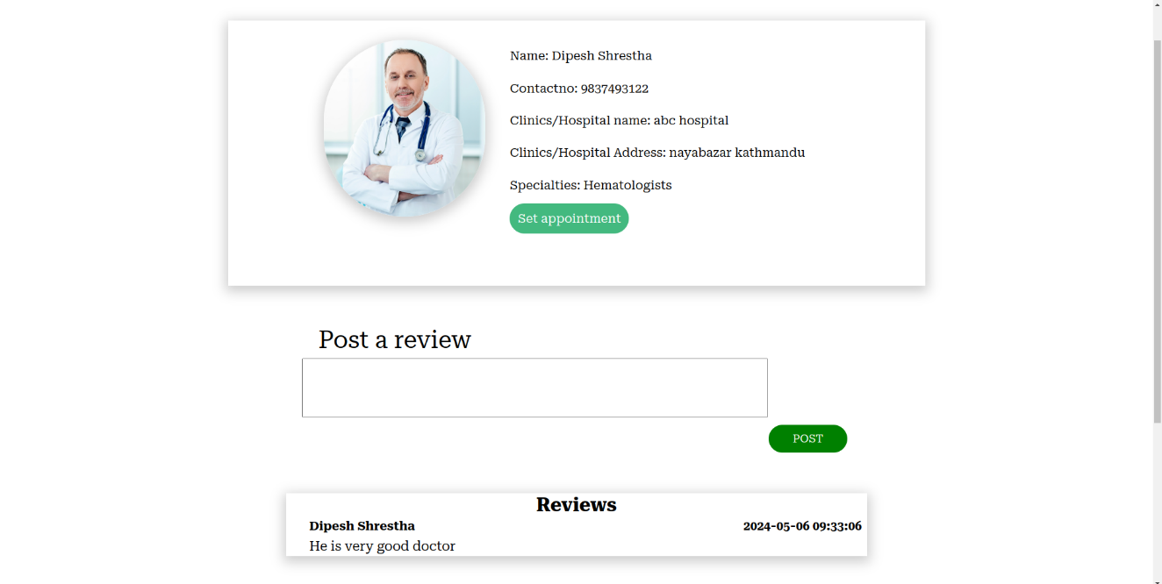

* **Appointment Page:**

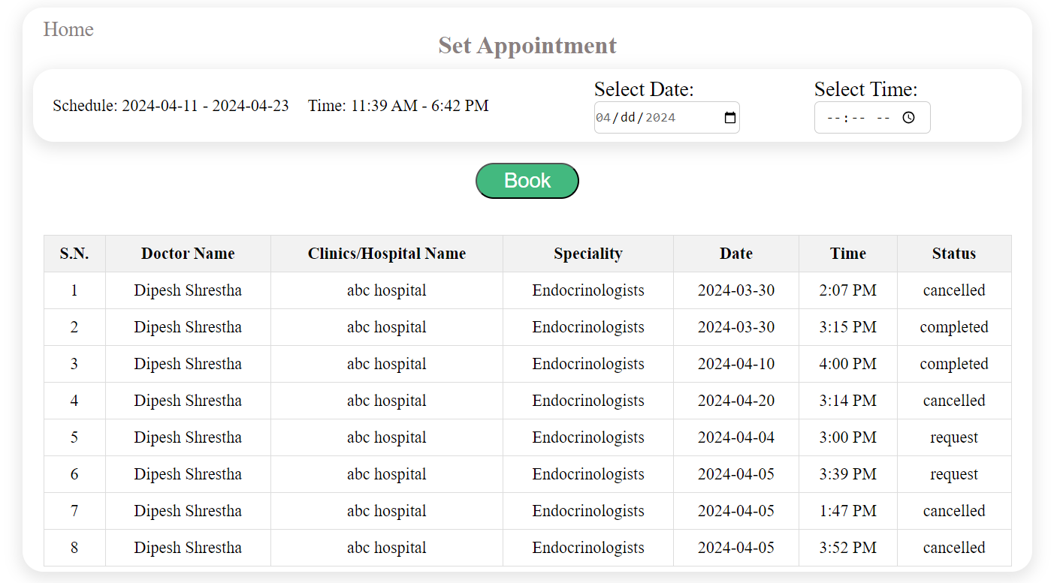

* **Booking Info Page:**

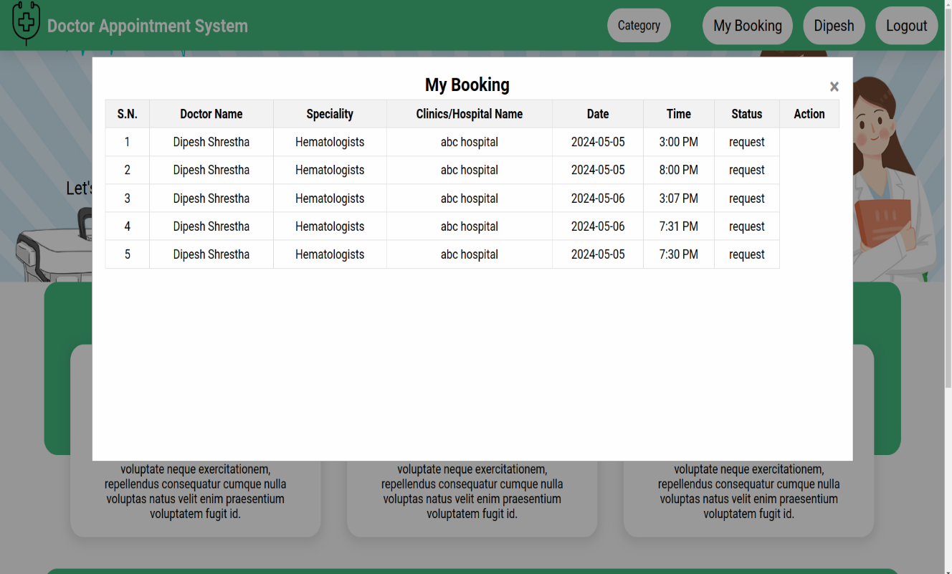

* **Doctor Dashboard**

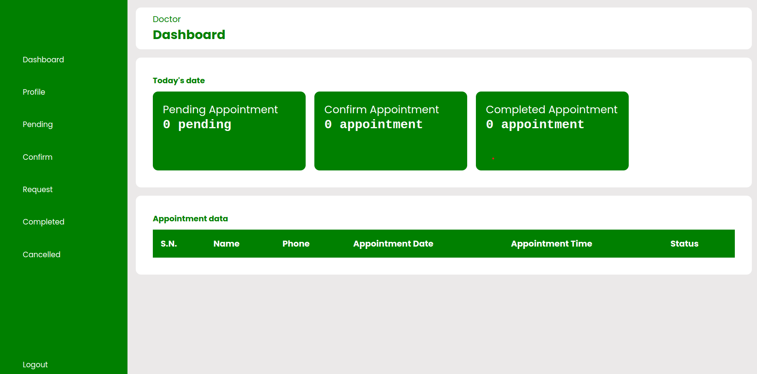

* **Admin Dashboard**

